Data Structures and Algorithms in C++ - Fundamental Concepts

Hitarth Patel  
150096724046  
Jensen Huang

#Part 1: Theory Questions

Introduction to DSA

1. What are the basic principles of Object-Oriented Programming in C++?

→

* Encapsulation : Bundling data and methods that operate on that data within a single unit (class).
* Abstraction : Hiding implementation details and showing only necessary information to the outside world.
* Inheritance : Creating a new class based on an existing class, inheriting its properties and behavior.
* Polymorphism : Ability of an object to take on multiple forms, depending on the context

2. Explain the difference between arrays and vectors in C++.

→

* Fixed Size: Arrays have a fixed size that must be specified at compile time. Vectors, on the other hand, can grow or shrink dynamically at runtime.
* Memory Allocation: Arrays are allocated memory on the stack or statically, whereas vectors allocate memory on the heap.
* Operations: Vectors provide more operations like push_back, insert, erase, etc., making them more flexible and easier to use.

Arrays and Memory

3. Explain the difference between stack and heap memory allocation in C++.

→

* Stack Allocation: Memory is allocated and deallocated automatically when a function is called and returns. Variables allocated on the stack have a fixed size and scope.
* Heap Allocation: Memory is allocated and deallocated manually using operators new and delete. Heap allocation allows for dynamic memory allocation, but it requires manual memory management.

4. How does array indexing work in C++? What happens when we access an out-of-bounds Index?

→

* Valid Indexing: Accessing an array element within its bounds (from index 0 to size - 1) is valid and returns the corresponding element.
* Out-of-Bounds Access: Accessing an array element outside its bounds (less than 0 or greater than or equal to size) results in undefined behavior.

Time and Space Complexity

5. Analyze the space complexity difference between:

int arr[1000]; // Stack allocation

int* arr = new int[1000]; // Heap allocation

→

* The space complexity of stack allocation is O(1) because the memory is allocated and deallocated automatically, and the size is fixed.
* The space complexity of heap allocation is O(n) because the memory is allocated dynamically, and the size can vary.

6. What is the time complexity of vector operations in C++:

push_back()

insert() at beginning

pop_back()

→

* push_back: Amortized O(1)
* insert at beginning: O(n)
* pop_back: O(1)

Part 2: Practical Questions

Arrays and Vectors

1. Write a program demonstrating dynamic array manipulation:

// Create a program that:

// 1. Takes array size from user

// 2. Dynamically allocates an array

// 3. Fills it *with* values

// 4. Finds sum and average

// 5. Properly deallocates memory

int main() {

// Your code here

*return* 0;

}

→

#include <iostream>

using namespace std;

int **main**() {

int size;

cout << "Enter array size: ";

cin >> size;

int* arr = new int[size];

for (int i = 0; i < size; ++i) {

arr[i] = i * 10;

}

int sum = 0;

for (int i = 0; i < size; ++i) {

sum += arr[i];

}

double average = static_cast<double>(sum) / size;

cout << "Array elements: ";

for (int i = 0; i < size; ++i) {

cout << arr[i] << " ";

}

cout << "\nSum: " << sum << "\nAverage: " << average << **endl**;

delete[] arr;

return 0;}

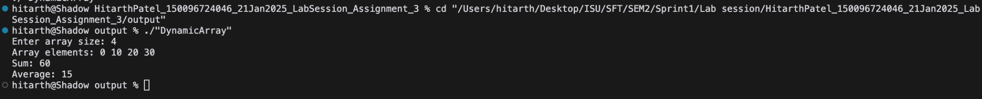

2. Implement array rotation using different techniques:

*// Write a class with methods to:*

*// 1. Rotate array using temporary array*

*// 2. Rotate array using one by one*

*// 3. Rotate array using reversal algorithm*

class ArrayRotation {

public:

void leftRotate(int *arr*[], int *size*, int *positions*);

void rightRotate(int *arr*[], int *size*, int *positions*);

void printArray(int *arr*[], int *size*);

};

→

#include <iostream>

using namespace std;

class ArrayRotation {

public:

void leftRotate(int *arr*[], int *size*, int *positions*) {

int* temp = new int[*positions*];

for (int i = 0; i < *positions*; ++i) {

temp[i] = *arr*[i];

}

for (int i = *positions*; i < *size*; ++i) {

*arr*[i - *positions*] = *arr*[i];

}

for (int i = 0; i < *positions*; ++i) {

*arr*[*size* - *positions* + i] = temp[i];

}

delete[] temp;

}

void rightRotate(int *arr*[], int *size*, int *positions*) {

for (int i = 0; i < *positions*; ++i) {

int temp = *arr*[*size* - 1];

for (int j = *size* - 1; j > 0; --j) {

*arr*[j] = *arr*[j - 1];

}

*arr*[0] = temp;

}

}

void leftRotateReversal(int *arr*[], int *size*, int *positions*) {

reverse(*arr*, 0, *positions* - 1);

reverse(*arr*, *positions*, *size* - 1);

reverse(*arr*, 0, *size* - 1);

}

void rightRotateReversal(int *arr*[], int *size*, int *positions*) {

reverse(*arr*, 0, *size* - 1);

reverse(*arr*, 0, *positions* - 1);

reverse(*arr*, *positions*, *size* - 1);

}

void printArray(int *arr*[], int *size*) {

for (int i = 0; i < *size*; ++i) {

cout << *arr*[i] << " ";

}

cout << **endl**;

}

private:

void reverse(int *arr*[], int *start*, int *end*) {

while (*start* < *end*) {

int temp = *arr*[*start*];

*arr*[*start*] = *arr*[*end*];

*arr*[*end*] = temp;

*start*++;

*end*--;

}

}

};

int **main**() {

int size;

cout << "Enter array size: ";

cin >> size;

int* arr = new int[size];

cout << "Enter array elements: ";

for (int i = 0; i < size; ++i) {

cin >> arr[i];

}

int positions;

cout << "Enter positions to rotate: ";

cin >> positions;

ArrayRotation rotation;

rotation.leftRotate(arr, size, positions);

cout << "Left rotated array: ";

rotation.printArray(arr, size);

rotation.rightRotate(arr, size, positions);

cout << "Right rotated array: ";

rotation.printArray(arr, size);

rotation.leftRotateReversal(arr, size, positions);

cout << "Left rotated array using reversal: ";

rotation.printArray(arr, size);

rotation.rightRotateReversal(arr, size, positions);

cout << "Right rotated array using reversal: ";

rotation.printArray(arr, size);

delete[] arr;

return 0;

}

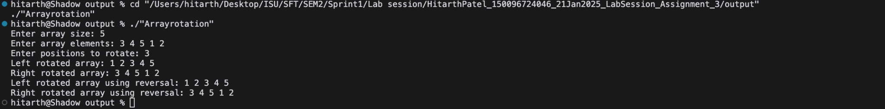

Searching

3. Implement Linear Search with templates:

*// Create a template function that can search any data type*

template<typename T>

int **linearSearch**(T *arr*[], int *size*, T *key*) {

*// Your code here*

}

→

#include <iostream>

using namespace std;

template <typename T>

int **linearSearch**(T *arr*[], int *size*, T *key*) {

for (int i = 0; i < *size*; ++i) {

if (*arr*[i] == *key*) {

return i;

}

}

return -1;

}

int **main**() {

int size;

cout << "Enter the size of the array: ";

cin >> size;

int* arr = new int[size];

cout << "Enter the elements of the array: ";

for (int i = 0; i < size; ++i) {

cin >> arr[i];

}

int key;

cout << "Enter the key to search: ";

cin >> key;

int result = **linearSearch**(arr, size, key);

if (result != -1) {

cout << "Element found at index " << result << **endl**;

} else {

cout << "Element not found" << **endl**;

}

delete[] arr;

return 0;

}



4. Implement Binary Search with error handling:

class BinarySearch {

public:

*// Return -1 if element not found*

*// Throw exception if array is not sorted*

int search(int *arr*[], int *size*, int *key*);

private:

bool isSorted(int *arr*[], int *size*);};

→

#include <iostream>

#include <stdexcept>

using namespace std;

class BinarySearch {

public:

int search(int *arr*[], int *size*, int *key*) {

if (!isSorted(*arr*, *size*)) {

throw invalid_argument("Array is not sorted");

}

int low = 0;

int high = *size* - 1;

while (low <= high) {

int mid = low + (high - low) / 2;

if (*arr*[mid] == *key*) {

return mid;

} else if (*arr*[mid] < *key*) {

low = mid + 1;

} else {

high = mid - 1;

}

}

return -1;

}

private:

bool isSorted(int *arr*[], int *size*) {

for (int i = 0; i < *size* - 1; ++i) {

if (*arr*[i] > *arr*[i + 1]) {

return false;

}

}

return true;

}

};

int **main**() {

int size;

cout << "Enter array size: ";

cin >> size;

int* arr = new int[size];

cout << "Enter array elements: ";

for (int i = 0; i < size; ++i) {

cin >> arr[i];

}

int key;

cout << "Enter the key to search: ";

cin >> key;

BinarySearch search;

try {

int result = search.search(arr, size, key); if (result != -1) {

cout << "Element found at index " << result << std::**endl**;

} else {

cout << "Element not found" << std::**endl**;

}

} catch (const std::exception& e) {

cerr << "Error: " << e.what() << std::**endl**;

}

delete[] arr;

return 0;

}



Sorting

5. Implement Selection Sort with comparison operator overloading:

class Student {

string name;

int score;

public:

*// Constructor*

*// Overload < operator for comparison*

*// Getters and setters*

};

void **selectionSort**(Student *arr*[], int *size*);

Requirements:

- Proper input validation

- Exception handling

- Performance measurement using `chrono` library

- Memory leak prevention

- Documentation using comments

→

#include <iostream>

#include <chrono>

#include <stdexcept>

class Student {

private:

std::string name;

int score;

public:

Student(std::string *name*, int *score*) : name(*name*), score(*score*) {}

bool operator<(const Student& *other*) const {

return score < *other*.score;

}

std::string getName() const {

return name;

}

int getScore() const {

return score;

}

void setName(const std::string& *name*) {

this->name = *name*;

}

void setScore(int *score*) {

this->score = *score*;

}

};

void **selectionSort**(Student *arr*[], int *size*) {

if (*arr* == nullptr || *size* <= 0) {

throw std::invalid_argument("Invalid input");

}

for (int i = 0; i < *size* - 1; ++i) {

int minIndex = i;

for (int j = i + 1; j < *size*; ++j) {

if (*arr*[j] < *arr*[minIndex]) {

minIndex = j;

}

}

if (minIndex != i) {

Student temp = *arr*[i];

*arr*[i] = *arr*[minIndex];

*arr*[minIndex] = temp;

}

}

}

int **main**() {

try {

Student students[] = {Student("John", 85), Student("Alice", 95), Student("Bob", 75)};

int size = sizeof(students) / sizeof(students[0]);

auto start = std::chrono::high_resolution_clock::now();

**selectionSort**(students, size);

auto end = std::chrono::high_resolution_clock::now();

std::cout << "Sorted array:" << std::**endl**;

for (int i = 0; i < size; ++i) {

std::cout << students[i].getName() << ": " << students[i].getScore() << std::**endl**;

}

auto duration = std::chrono::**duration_cast**<std::chrono::microseconds>(end - start);

std::cout << "Time taken: " << duration.count() << " microseconds" << std::**endl**;

} catch (const std::exception& e) {

std::cerr << "Error: " << e.what() << std::**endl**;

return 1;

}

return 0;

}

* Proper input validation: The selectionSort function checks for valid input, including a non-null array and a positive size.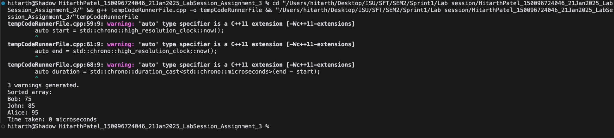
* Exception handling: The code catches and handles exceptions that may occur during execution.
* Performance measurement: The code uses the chrono library to measure the time taken to perform the selection sort.
* Memory leak prevention: The code does not allocate memory dynamically, eliminating the risk of memory leaks.
* Documentation: The code includes comments to explain its functionality and purpose.